**Assignment no 2**

**1 .Explain in detail Project management attributes**

A **project** can be defined as a temporary endeavour undertaken to accomplish a unique product, services or results.

Project can be sequences of task which is planned from beginning to end bounded by time, resources, and required result.

The Following are the attributes of Project:

**a. Time frame:** Because a project is a temporary endeavour, it must have a definite beginning and end. Many projects begin on a specific date and the date of completion is estimated. Some project has an immovable date when the project must be completed.

**b. Purpose:** An IT Project can produce any number of results such as a system, a software package, or a recommendation based on a study. Therefore a project’s goal must be to produce something tangible and of value to the organization. A Project must have a goal to drive the project in terms of defining the work to be done.

**c. Ownership:** The project must provide something of value to an individual or group who will own the project product after it is completed. Determining who owns this project is not always easy. For example, different groups may fight over the does and does not own the system, the data, the support, and the final cost of implementing and maintaining the system.

**d. Resources:** IT project require time, money, people, and technology. Resources provide the means for achieving a project’s goal and also act as a constraint. For example, the project’s scope, or work to be accomplished is determined directly by the project’s goal. If project sponsor asks that an additional feature to be added to the system, however, this will required additional resources in terms of more work on the part of project team.

**e. Roles:** IT Projects require different individuals with different skills set, they are listed below.

**2. Explain in detail project scheduling**

**Project schedule** simply means a mechanism that is used to communicate and know about that tasks are needed and has to be done or performed and which organizational resources will be given or allocated to these tasks and in what time duration or time frame work is needed to be performed. Effective project scheduling leads to success of project, reduced cost, and increased customer satisfaction. Scheduling in project management means to list out activities, deliverables, and milestones within a project that are delivered. It contains more notes than your average weekly planner notes. The most common and important form of project schedule is Gantt chart.

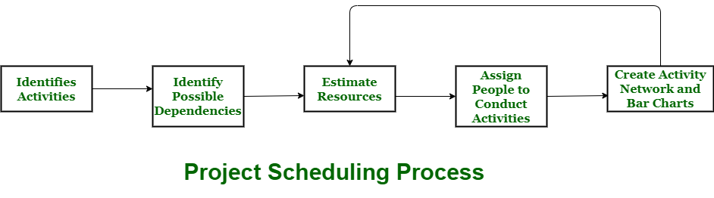 **Process**

The manager needs to estimate time and resources of project while scheduling project. All activities in project must be arranged in a coherent sequence that means activities should be arranged in a logical and well-organized manner for easy to understand. Initial estimates of project can be made optimistically which means estimates can be made when all favorable things will happen and no threats or problems take place.

The total work is separated or divided into various small activities or tasks during project schedule. Then, Project manager will decide time required for each activity or task to get completed. Even some activities are conducted and performed in parallel for efficient performance. The project manager should be aware of fact that each stage of project is not problem-free.

**3. Explain in detail cocomo model**

Cocomo (Constructive Cost Model) is a regression model based on LOC, i.e **number of Lines of Code**. It is a procedural cost estimate model for software projects and often used as a process of reliably predicting the various parameters associated with making a project such as size, effort, cost, time and quality. It was proposed by Barry Boehm in 1970 and is based on the study of 63 projects, which make it one of the best-documented models.

The key parameters which define the quality of any software products, which are also an outcome of the Cocomo are primarily Effort & Schedule:

* **Effort:** Amount of labor that will be required to complete a task. It is measured in person-months units.
* **Schedule:** Simply means the amount of time required for the completion of the job, which is, of course, proportional to the effort put. It is measured in the units of time such as weeks, months.

Different models of Cocomo have been proposed to predict the cost estimation at different levels, based on the amount of accuracy and correctness required. All of these models can be applied to a variety of projects, whose characteristics determine the value of constant to be used in subsequent calculations. These characteristics pertaining to different system types are mentioned below.

Boehm’s definition of organic, semidetached, and embedded systems:

1. **Organic –** A software project is said to be an organic type if the team size required is adequately small, the problem is well understood and has been solved in the past and also the team members have a nominal experience regarding the problem.
2. **Semi-detached –** A software project is said to be a Semi-detached type if the vital characteristics such as team-size, experience, knowledge of the various programming environment lie in between that of organic and Embedded. The projects classified as Semi-Detached are comparatively less familiar and difficult to develop compared to the organic ones and require more experience and better guidance and creativity. Eg: Compilers or different Embedded Systems can be considered of Semi-Detached type.
3. **Embedded –** A software project with requiring the highest level of complexity, creativity, and experience requirement fall under this category. Such software requires a larger team size than the other two models and also the developers need to be sufficiently experienced and creative to develop such complex models.

All the above system types utilize different values of the constants used in Effort Calculations.

**4. Explain in detail risk management**

**Risk Management**

A software project can be concerned with a large variety of risks. In order to be adept to systematically identify the significant risks which might affect a software project, it is essential to classify risks into different classes. The project manager can then check which risks from each class are relevant to the project.

There are three main classifications of risks which can affect a software project:

1. Project risks
2. Technical risks
3. Business risks

**1. Project risks:** Project risks concern differ forms of budgetary, schedule, personnel, resource, and customer-related problems. A vital project risk is schedule slippage. Since the software is intangible, it is very tough to monitor and control a software project. It is very tough to control something which cannot be identified. For any manufacturing program, such as the manufacturing of cars, the plan executive can recognize the product taking shape.

**2. Technical risks:** Technical risks concern potential method, implementation, interfacing, testing, and maintenance issue. It also consists of an ambiguous specification, incomplete specification, changing specification, technical uncertainty, and technical obsolescence. Most technical risks appear due to the development team's insufficient knowledge about the project.

**3. Business risks:** This type of risks contain risks of building an excellent product that no one need, losing budgetary or personnel commitments, etc.

**Other risk categories**

1. **1. Known risks:** Those risks that can be uncovered after careful assessment of the project program, the business and technical environment in which the plan is being developed, and more reliable data sources (e.g., unrealistic delivery date)
2. **2. Predictable risks:** Those risks that are hypothesized from previous project experience (e.g., past turnover)
3. **3. Unpredictable risks:** Those risks that can and do occur, but are extremely tough to identify in advance.